Switch in ARM (jump table)

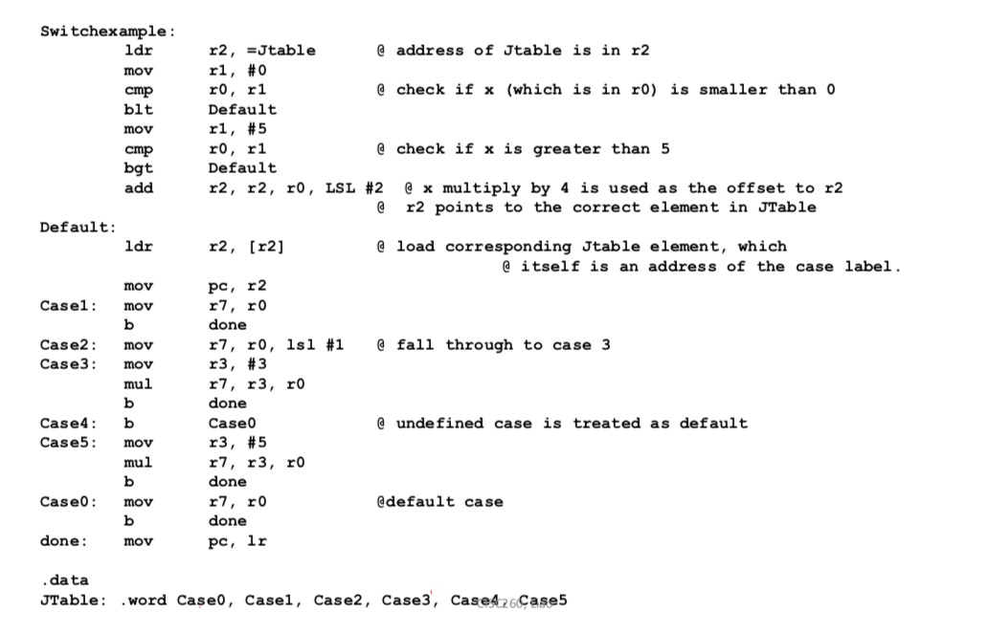

Drawback: When the range is large and cases are sparse, the jumptable becomes not space economical. A chained if-then-else is a better option for such situations.

-Tail recursion:

• when no further computation follows a recursive call;  
• can be easily converted to iteration (automatically by the compiler);

• no stack overhead is needed any more.

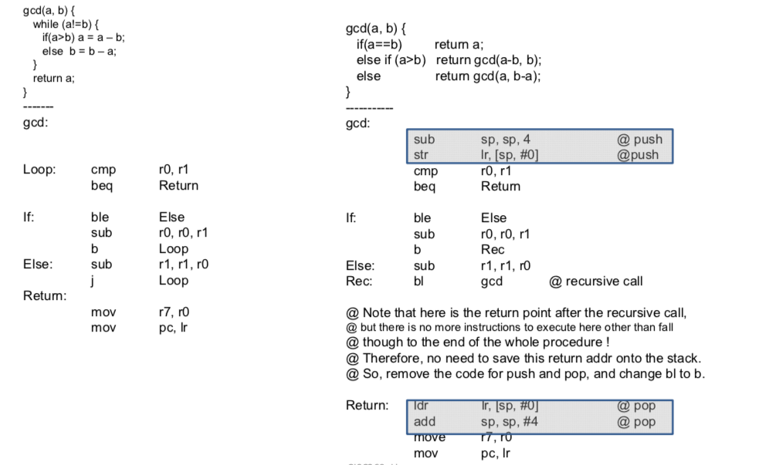

Loop Invariant & Efficiency:

